Title | Steven Krauwer Awards 2017, call for nominations | 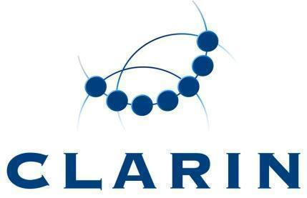
Version | 1.2
Author(s) | KDS+MP
Document Date | 2017-06-21
Status | Final
Distribution | NCF
ID | CE-2017-1232

Steven Krauwer Awards 2018, call for nominations

Description
These awards, named in honour of Steven Krauwer (the first executive director of CLARIN ERIC) are given annually to outstanding scientists or engineers in recognition of outstanding contributions toward CLARIN goals in the areas of language resource building, tool or service development, exemplary use cases, user involvement or knowledge sharing.

Categories
In 2018, Steven Krauwer Awards will be given in the following categories:
1. Young CLARIN Researcher. The intended goal of this award is to promote a young person or a group of cooperating young persons below the age of 35.
2. CLARIN Achievement. The intended goal of this award is to recognize the work of a person or a group of cooperating people.

Prize
A certificate will be given to each recipient; in addition, the prize for Young CLARIN Researcher will be 500 Euro.

Eligibility
The award recipients must be researchers or engineers working in any of the countries or regions covered by CLARIN ERIC members, CLARIN ERIC observers or partners that have an agreement with CLARIN ERIC according to article 18 of the Statutes.
Each recipient of the award for Young CLARIN Researcher should not have reached the age of 35 years on December 31, 2018.
Each recipient of the award for CLARIN achievements should be a single person or a group of named people who have closely cooperated with each other.

Selection
The recipients will be selected by the National Coordinators’ Forum (NCF) of CLARIN ERIC. The NCF is responsible for establishing the procedure for reviewing the nominees’ work and for selecting the award recipients.

Presentation
There will be a prize ceremony at the CLARIN Annual Conference.

Nomination
Nominators and nominees must be working in the countries or regions covered by CLARIN ERIC members or by CLARIN ERIC observers.
Nominators should provide a written account of the nominees' work and the reasons it is felt to be an outstanding contribution to CLARIN. A list of bibliographic references to the nominees' work, relevant links to language resources, language tools, use cases, user involvement, knowledge sharing and/or other related activities by the nominees are desirable.
Nominations should state the names, affiliations and contact details of all nominators and should be sent to the Chair of the NCF, Maciej Piasecki, by e-mail to maciej.piasecki@pwr.edu.pl.

Nomination Deadline for 2018
1st September, 2018, 13:00 CET.

