Title | Website requirement specification
Version | 2
Author(s) | Dieter Van Uytvanck
Date | 2016-05-31
Status | Draft
Distribution | Web Committee, BoD
ID | CE-2016-0792

Requirement list

Description of requirements

GUI editor (CK editor)
Re-enable the CK editor for editing of HTML. Is dependent on the new Drupal theme.

Technical description: https://trac.clarin.eu/ticket/873 (Sander)

Connection to the centre registry
The currently used implementation might be dependent on the old theme. Also it is too much undocumented custom code to maintain. First try to manually shape the information at https://www.clarin.eu/clarin-eric-datatables/centres/1 in a better form and then the automatic connection can be made using standard Drupal modules.

Technical description: https://trac.clarin.eu/ticket/938 (Sander, Dieter)

New Drupal theme

Provide a bootstrap-based theme that is in line with the CLARIN human interface guidelines (Sander). Is dependent on the delivery of the human interface guidelines (Amir).

New front-page

Create a new drupal view for the frontpage (Sander, Dieter). See mock-up below (Amir, Martin).

New menu structure

Create a simpler menu structure (less levels of hierarchy). Depends on:
- Restructuring of the information on clarin.eu (Linda, Sebastian, Martin, Dieter)
- Finding and implementing a good bootstrap-compliant implementation, e.g. http://alijafarian.com/bootstrap-multi-column-dropdown-menu/ (Amir and Sander)

Priorisation

Requirement | Priority (1 =low .. 5= high)
GUI editor (CK editor) | 4
Connection to the centre registry | 3
New Drupal theme | 5
New front-page | 5
New menu structure | 5

Mock-up of the frontpage
Graphical impression using the new housestyle, not including yet the new menu and front page elements.

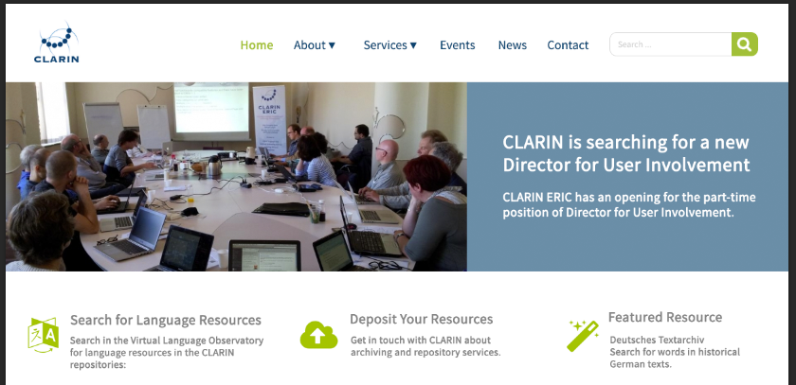

Navigation and structure
At a meeting in Utrecht, the following blocks below the featured article/showcase/event/resource were proposed:

About CLARIN
[short introduction + more link]

Services (maybe rephrase as suggested by Martin: Services, Tools & Data)
[short introduction + link to single landing page, similar to http://www.clarin.eu/services]

Member Countries
[short introduction + link to single landing page, which will contain links to a page on clarin.eu with information about the consortia; the consortium will be able to edit the content of that page]

The top Menu will be (in this order):

- About (multi-column drop-down as suggested in scenario 4 of this Excel
- Services (simple link to landing page)
- Member Countries (simple link to landing page)
- Events (simple link to Drupal view like https://www.clarin.eu/events)
- News (simple link to Drupal view like https://www.clarin.eu/news-portal)
- Contact (simple link to page like https://www.clarin.eu/contact)

The current twitter feed on the front page will be replaced by a set of social media icons in the footer of the site, including the link to CLARIN ERIC’s twitter account.

Suggested migration procedure

- 2 June: Sander installs the development version (copy of of clarin.eu) on dev-www.clarin.eu
- 9 June: basic modules/menus installed, data syncronisation from production version
- 13-17 June: www.clarin.eu in read-only mode, changes (new menu structure, content) are all made to dev-www.clarin.eu
- 18-21 June: feedback from NCF
- 22 June: the new version as created at dev-www will be deployed at www.clarin.eu ; site will be writeable again

